
SHIRE HIGHLANDS EDUCATION DIVISION
2025 MALAWI SCHOOL CERTIFICATE OF EDUCATION MOCK
EXAMINATION

BIOLOGY
Subject Number: M022/I
Wednesday, 26th March Time Allowed: 2 hours
8:00-10:00am

PAPER I
(100 Marks)

THEORY
Question Number | Tick if answered | Do not write these columns
1
2
3
4
5
6
7
8
9
10
11
12
13
14
TOTAL
Instructions
- This paper contains 8 printed pages. Please check.
- Before you begin, fill your Name at the top of each page in the spaces provided.

- This paper has two sections, A and B. Section A has eleven questions and Section B has three questions.

- Answer all the 7 questions in the spaces provided. The maximum number of marks for each question is indicated against each question.

- In the table provided on this page, tick against the number of the question you have answered.

©2025 SHED MOCK Turn over/…
SECTION A (70 marks)
Answer all questions in this section in the spaces provided
- a. State any two factors that increase the risk of cancer ____________________________________________________________________________________________________________________________________________________(2 marks)
b. List down any two measures of controlling and preventing diseases at household levels. ______________________________________________________________________________________________________________________________________________(2marks)
c. Figure 1 shows structure of a human heart
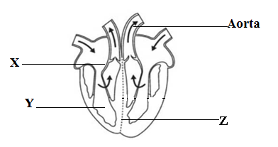
Figure 1: Human heart
(i). Name the parts labelled X and Y
X_____________________________________________________________ (1 mark)
Y_______________________________________________________________(1mark)
(ii). Explain the role of part labelled Z during blood circulation _____________________________________________________________________________________________________________________________________________________________________________________________________________________________________________________________________________________(2marks)
- a (i) Name the organelle in living cells in which aerobic respiration occurs.
__________________________________________________________________ (1 mark)
(ii) State any one adaptation of the organelle mentioned in 2a(i) above to its function. ___________________________________________________________________(1 mark)
b. Describe any one economic importance of anaerobic respiration. ______________________________________________________________________________________________________________________________________________(2 marks)
- a. Give any two examples of digestive enzymes _____________________________________________________________________________________________________________________________________________________(2marks)
b. Which part of large intestines is responsible for temporary storage of faecal matter. ______________________________________________________________________(1mark)
c. Describe any one property of digestive enzymes. _______________________________________________________________________________________________________________________________________________(2marks)
d. Explain any one problem associated with digestive system _______________________________________________________________________________________________________________________________________________(2marks)
- Figure 2 shows the structure of a nephrone. Use it to answer the questions that follow.
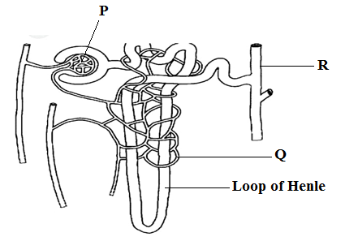
Figure 2: The Nephrone
- Which part is largely affected by an increase in antidiuretic hormone in blood.
___________________________________________________________________(1mark)
- What role does structure Q play in the excretion process
________________________________________________________________(1mark)
- Describe the process which occurs at part labelled P.
________________________________________________________________________________________________________________________________________(2marks)
- Figure 3 shows a transverse section of a stem of a flowering plant. Use it to answer the questions that follow.
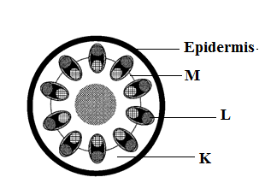
Figure 3: Transverse section of a stem of flowering plant
- Name the group of flowering plants from which the stem was drawn. Give a reason for your answer.
______________________________________________________________________________________________________________________________________________(2marks)
- Mention the two types of cells which make up part labelled L.
______________________________________________________________________________________________________________________________________________(2marks)
- State any two substances which are stored in part marked K.
______________________________________________________________________________________________________________________________________________(2marks)
- Describe the function of part marked M.
______________________________________________________________________________________________________________________________________________(2marks)

- a. State any two types of hydrophytes
________________________________________________________________________________________________________________________________________________(2marks)
b. Give any two adaptations of hydrophytes which help to keep them buoyant.
________________________________________________________________________________________________________________________________________________(2marks)
c. Describe any one role of a camel hump in the desert ________________________________________________________________________________________________________________________________________________(2marks)
- Figure 4 shows a path taken by a spinal reflex action. Use it to answer the questions that follow.
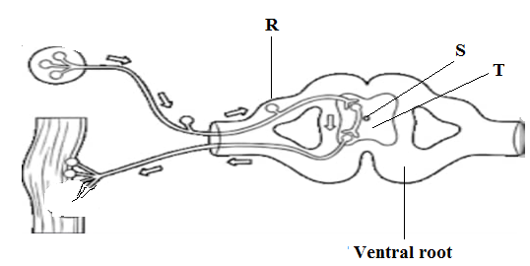
Figure 4: Path taken by a reflex action

- What name is given to the path shown above. ____________________________________________________________________(1mark)
- Name the parts marked R and T
R___________________________________________________________________(1mark)
T___________________________________________________________________(1mark)
- Explain any two functions of the fluid present in part S.
____________________________________________________________________________________________________________________________________________________________________________________________________________________________________________________________________________________________________(4marks)

- a. Mention the structures which are used for gaseous exchange in the following vertebrates.
- Mammals __________________________________________________________________(1mark)
(ii). Fish __________________________________________________________________(1mark)
b. State any one adaptation of a flight feather of bird to its function.
____________________________________________________________________(1mark)
c. Explain how upstroke is achieved during the flapping movements in birds.
____________________________________________________________________________________________________________________________________________________________________________________________________________________________(3marks)
- A woman with blood group A gets married to a man with blood group B. Their first-born daughter when tested for blood group is found to be blood group O.

  - Write down the genotype of the man and woman
________________________________________________________________________________________________________________________________________________(2marks)
  - Show using a genetic cross diagram how the first born daughter inherited the blood group.

    - marks)

c. In addition to genetic counselling, state any other two applications of biotechnology. _____________________________________________________________________________________________________________________________________________(2marks)
- Describe any one ethical issue in biotechnology.
_________________________________________________________________________________________________________________________________________________________________________________________________________________________(2marks)

- a. What are mutations?
_________________________________________________________________________________________________________________________________________________(1mark)
b. Describe how mutations can lead to evolution.
________________________________________________________________________________________________________________________________________________(2marks)
c. State any two evidences of evolution.
________________________________________________________________________________________________________________________________________________(2marks)

- a. Mention any two forces which help water to flow up the xylem vessels.
____________________________________________________________________________________________________________________________________________________________________________________________________________________________(2marks)
b. Explain how an increase in humidity affects the rate of transpiration in plants.
____________________________________________________________________________________________________________________________________________________________________________________________________________________________(2marks)
SECTION B (30marks)
Answer all the three questions in this section in the spaces provided under each question. Your answers should be in an essay form
- Describe any five sources of water pollution in Lake Malawi.
________________________________________________________________________________________________________________________________________________________________________________________________________________________________________________________________________________________________________________________________________________________________________________________________________________________________________________________________________________________________________________________________________________________________________________________________________________________________________________________________________________________________________________________________________________________________________________________________________________________________________________________________________________________________________________________________________________________________________________________________________________________________________________________________________________________________________________________________________________________________________________________________________________________________________________________________________________________________________________________________________________________________________________________________________________________________________________________________________________________________________________________________________________________________________________________________________________________________________________________________________________________________________________________________________________________________________________________________________________________________________________________________________________________________________________________________________________________________________________________________________________________________________________________________________________________________________________________________________________________________________________________________________________________________________________________________(10marks)

- Explain five adaptations of alveoli for gaseous exchange.
___________________________________________________________________________________________________________________________________________________________________________________________________________________________________________________________________________________________________________________________________________________________________________________________________________________________________________________________________________________________________________________________________________________________________________________________________________________________________________________________________________________________________________________________________________________________________________________________________________________________________________________________________________________________________________________________________________________________________________________________________________________________________________________________________________________________________________________________________________________________________________________________________________________________________________________________________________________________________________________________________________________________________________________________________________________________________________________________________________________________________________________________________________________________________________________________________________________________________________________________________________________________________________________________________________________________________________________________________________________________________________________________________________________________________________________________________________________________________________________________________________________________________________________________________________________________________________________________________________________________________________________________________________________________________________________________________________________________________________________________________________________________________________________________________________________________(10 marks)

- Describe any five abnormal conditions of the kidneys which can cause kidney failure. ____________________________________________________________________________________________________________________________________________________________________________________________________________________________________________________________________________________________________________________________________________________________________________________________________________________________________________________________________________________________________________________________________________________________________________________________________________________________________________________________________________________________________________________________________________________________________________________________________________________________________________________________________________________________________________________________________________________________________________________________________________________________________________________________________________________________________________________________________________________________________________________________________________________________________________________________________________________________________________________________________________________________________________________________________________________________________________________________________________________________________________________________________________________________________________________________________________________________________________________________________________________________________________________________________________________________________________(10marks)

END OF QUESTION PAPER

